**Market Place Technical**

**Foundation-**

**Comforty(Template 8)**

**Name: Abdullah Shaikh Day-4 Building dynamic Front-end components**

# Header:

In my header component there are three components:

It’s component code is:

import TopHeader from "../top_header/page";

import BottomHeader from "../bottom_header/page";

import Navbar from "../navbar/page";

*const* Header = () *=>* {

  return (

    <div className="w-full">

      <*TopHeader*/>

      <*BottomHeader*/>

      <*Navbar*/>

      <div className="w-full h-[2px] bg-[#F0F2F3]"/>

    </div>

  );

}

export default Header;

## Top Header:

This is a responsive component of my website and the toppest component which code is:

import Link from 'next/link';

*const* TopHeader = () *=>* {

    return (

        <div className="flex items-center h-[45px] w-full bg-[#272343]

    px-[15.625%] text-white justify-between text-[13px] font-inter font-normal exsm:text-[8px]">

            <div className="flex gap-2 items-center">

                <div>

                    <svg width="14" height="10" viewBox="0 0 14 10" fill="none" xmlns="http://www.w3.org/2000/svg">

                        <path d="M12.3334 1.5L5.00008 8.83333L1.66675 5.5" stroke="white" strokeWidth="1.5" strokeLinecap="round" strokeLinejoin="round" />

                    </svg>

                </div>

                <p>

                    Free shipping on all orders over $50

                </p>

            </div>

            <div className="flex items-center gap-[19.2px] exsm:gap-2">

                <div className="flex items-center gap-1">

                    <p>Eng</p>

                    <div>

                        <svg width="9" height="5" viewBox="0 0 9 5" fill="none" xmlns="http://www.w3.org/2000/svg">

                            <path d="M8 0.75L4.5 4.25L1 0.75" stroke="white" strokeLinecap="round" strokeLinejoin="round" />

                        </svg>

                    </div>

                </div>

                <div className="flex items-center">

                    <*Link* href="/components/faqsPage">Faqs</*Link*>

                </div>

                <div className="flex gap-1 items-center">

                    <div>

                        <svg width="16" height="16" viewBox="0 0 16 16" fill="none" xmlns="http://www.w3.org/2000/svg">

                            <g opacity="0.7" clipPath="url(#clip0_1_883)">

                                <path d="M7.99992 14.6667C11.6818 14.6667 14.6666 11.6819 14.6666 8.00004C14.6666 4.31814 11.6818 1.33337 7.99992 1.33337C4.31802 1.33337 1.33325 4.31814 1.33325 8.00004C1.33325 11.6819 4.31802 14.6667 7.99992 14.6667Z" stroke="white" strokeLinecap="round" strokeLinejoin="round" />

                                <path d="M8 5.33337V8.00004" stroke="white" strokeLinecap="round" strokeLinejoin="round" />

                                <path d="M8 10.6666H8.00615" stroke="white" strokeLinecap="round" strokeLinejoin="round" />

                            </g>

                            <defs>

                                <*clipPath* id="clip0_1_883">

                                    <rect width="16" height="16" fill="white" />

                                </*clipPath*>

                            </defs>

                        </svg>

                    </div>

                    <p>Need Help</p>

                </div>

            </div>

        </div>

    )

}

export default TopHeader;

## Bottom Header:

It is also responsive and shows a navbar icon which shows a dropdown navbar on small screens its code is:

"use client";

import { useState } from "react";

import Image from "next/image"

import Link from "next/link";

import { useSelector } from "react-redux";

import { cartType } from "@/app/features/cartSlice";

*const* BottomHeader = () *=>* {

*const* [isOpen, setIsOpen] = useState(false);

*const* cartt = useSelector((*state*: { cart: cartType }) *=>* *state*.cart);

*const* cart = cartt.cartItems;

    return (

        <div className="flex items-center  h-[84px]

    bg-[#F0F2F3] justify-between 2xl:px-[15.625%] xl:px-[206px] lg:px-[175px] md:px-[125px] sm:px-[106px] exsm:px-[40px]">

            <div className="flex gap-1">

                <*Image* src="/logo.png" height={40} width={40} alt="Logo"

                />

                <h2 className="font-medium font-inter text-[26px] ">Comforty</h2>

            </div>

            <div className="flex items-center gap-2">

            <*Link* href="/components/cart" className="flex items-center h-11  bg-[#fff]

            rounded-[8px] px-3 gap-2 w-auto">

                <svg width="22" height="22" viewBox="0 0 22 22" fill="none" xmlns="http://www.w3.org/2000/svg" className="exsm:hidden">

                    <path d="M2.52081 2.97913L4.42748 3.30913L5.31023 13.826C5.34414 14.2399 5.53284 14.6257 5.83867 14.9066C6.14451 15.1875 6.545 15.3427 6.96023 15.3413H16.9611C17.3586 15.3417 17.743 15.1986 18.0435 14.9382C18.344 14.6778 18.5403 14.3177 18.5964 13.9241L19.4672 7.91263C19.4904 7.75275 19.4819 7.58987 19.4421 7.43329C19.4023 7.27671 19.3321 7.12951 19.2354 7.00011C19.1387 6.8707 19.0174 6.76163 18.8785 6.67913C18.7396 6.59663 18.5858 6.54231 18.4259 6.51929C18.3672 6.51288 4.73365 6.50829 4.73365 6.50829" stroke="#272343" strokeWidth="1.5" strokeLinecap="round" strokeLinejoin="round" />

                    <path d="M12.9479 9.89539H15.4898" stroke="#272343" strokeWidth="1.5" strokeLinecap="round" strokeLinejoin="round" />

                    <path fillRule="evenodd" clipRule="evenodd" d="M6.5578 18.5194C6.62502 18.5165 6.69213 18.5272 6.75509 18.551C6.81805 18.5747 6.87556 18.611 6.92414 18.6575C6.97273 18.704 7.01139 18.7599 7.03781 18.8218C7.06422 18.8837 7.07784 18.9503 7.07784 19.0176C7.07784 19.0849 7.06422 19.1515 7.03781 19.2133C7.01139 19.2752 6.97273 19.3311 6.92414 19.3777C6.87556 19.4242 6.81805 19.4605 6.75509 19.4842C6.69213 19.5079 6.62502 19.5187 6.5578 19.5158C6.42936 19.5103 6.30801 19.4554 6.21908 19.3626C6.13015 19.2697 6.08051 19.1461 6.08051 19.0176C6.08051 18.889 6.13015 18.7654 6.21908 18.6726C6.30801 18.5798 6.42936 18.5249 6.5578 18.5194Z" fill="#272343" stroke="#272343" strokeWidth="1.5" strokeLinecap="round" strokeLinejoin="round" />

                    <path fillRule="evenodd" clipRule="evenodd" d="M16.8988 18.5194C17.0312 18.5194 17.1583 18.572 17.252 18.6657C17.3457 18.7594 17.3983 18.8865 17.3983 19.019C17.3983 19.1515 17.3457 19.2786 17.252 19.3723C17.1583 19.4659 17.0312 19.5186 16.8988 19.5186C16.7663 19.5186 16.6392 19.4659 16.5455 19.3723C16.4518 19.2786 16.3992 19.1515 16.3992 19.019C16.3992 18.8865 16.4518 18.7594 16.5455 18.6657C16.6392 18.572 16.7663 18.5194 16.8988 18.5194Z" fill="#272343" stroke="#272343" strokeWidth="1.5" strokeLinecap="round" strokeLinejoin="round" />

                </svg>

                <p className="font-inter font-medium text-[12px]">

                    Cart

                </p>

                {cart.length==0?<></>:<div className="flex h-5 w-5 rounded-[50%] bg-[#173917]

                 text-white text-[10px] items-center

                  font-inter justify-center">

                    <p>{cart.length}</p>

                </div>}

            </*Link*>

            <div className="2xl:hidden xl:hidden lg:hidden md:flex sm:flex exsm:flex">

      <div className="">

        <button

          onClick={() *=>* setIsOpen(!isOpen)}

          className="text-[#007580] focus:outline-none"

        >

          {isOpen ? (

            <svg

              xmlns="http://www.w3.org/2000/svg"

              className="h-6 w-6"

              fill="none"

              viewBox="0 0 24 24"

              stroke="currentColor"

            >

              <path

                strokeLinecap="round"

                strokeLinejoin="round"

                strokeWidth="2"

                d="M6 18L18 6M6 6l12 12"

              />

            </svg>

          ) : (

            <svg

              xmlns="http://www.w3.org/2000/svg"

              className="h-6 w-6"

              fill="none"

              viewBox="0 0 24 24"

              stroke="currentColor"

            >

              <path

                strokeLinecap="round"

                strokeLinejoin="round"

                strokeWidth="2"

                d="M4 6h16M4 12h16M4 18h16"

              />

            </svg>

          )}

        </button>

      </div>

      {isOpen && (

        <ul className="absolute top-[150px] left-0 w-full bg-white shadow-md  flex-col items-center gap-5 py-4 text-[#636270] font-inter font-medium text-[14px] hidden md:flex sm:flex exsm:flex">

          <*Link* href="/pages/home" onClick={()*=>*setIsOpen(!isOpen)}>

            <li className="hover:text-[#007580]">Home</li>

          </*Link*>

          <*Link* href="" onClick={()*=>*setIsOpen(!isOpen)}>

            <li className="hover:text-[#007580]">Shop</li>

          </*Link*>

          <*Link* href="/pages/products" onClick={()*=>*setIsOpen(!isOpen)}>

            <li className="hover:text-[#007580]">Product</li>

          </*Link*>

          <*Link* href="">

            <li className="hover:text-[#007580]" onClick={()*=>*setIsOpen(!isOpen)}>Pages</li>

          </*Link*>

          <*Link* href="/components/aboutUs" onClick={()*=>*setIsOpen(!isOpen)}>

            <li className="hover:text-[#007580]">About</li>

          </*Link*>

          <*Link* href="/components/contactUs" onClick={()*=>*setIsOpen(!isOpen)}>

            <li className="hover:text-[#007580]">Contact: (808) 555-0111</li>

          </*Link*>

        </ul>

      )}

    </div>

            </div>

        </div>

    )

}

export default BottomHeader

## Navbar:

It is for not small screens as for small screen is in the bottom header and its code is:

import Link from "next/link";

*const* Navbar = () *=>* {

  return (

    <nav className="h-[74px] w-full

 2xl:px-[15.625%] xl:px-[206px] lg:px-[175px]  sm:hidden exsm:hidden md:hidden 2xl:flex xl:flex lg:flex items-center justify-between">

        <div>

            <ul className="flex gap-7 text-[#636270] font-inter

             font-medium text-[14px]">

                <*Link* href="/pages/home">

                <li className="hover:text-[#007580]">Home</li>

                </*Link*>

                <*Link* href="">

                <li className="hover:text-[#007580]">Shop</li>

                </*Link*>

                <*Link* href="/pages/products">

                <li className="hover:text-[#007580]">Product</li>

                </*Link*>

                <*Link* href="">

                <li className="hover:text-[#007580]">Pages</li>

                </*Link*>

                <*Link* href="/components/aboutUs">

                <li className="hover:text-[#007580]">About</li>

                </*Link*>

            </ul>

        </div>

        <*Link* href="/components/contactUs" className="flex">

            <p className="text-[#272343] font-inter font-medium

                 text-[14px">

                <span className="text-[#636270] font-inter font-medium

                 text-[14px]">

                    Contact:

                </span> (808) 555-0111

            </p>

        </*Link*>

    </nav>

  )

}

export default Navbar;

## Output of Header:

The output of the header is:

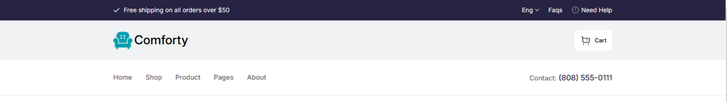

# Featured Products:

This component shows the products that have featured tag.

The code of the component is:

"use client";

import {useEffect, useState } from "react";

import ProductSectionComp, { Product } from "../productSection2";

import axios from"axios";

*const* FeaturedProducts = () *=>* {

  async *function* getData() {

*const* resp = await axios.get("/api/fetch/featured");

    setData(resp.data);

    }

*const* [data,setData] = useState<Product[]>([])

  useEffect(()*=>*{

    getData();

  })

  return (

    <div className='flex flex-col mt-6 pl-[15.625%] pr-[15.625%] gap-10'>

      <h3 className='font-inter font-semibold text-[32px]'>

        Featured Products</h3>

        <*ProductSectionComp* products={data}/>

    </div>

  )

}

export default FeaturedProducts;

## Output:

The output of featured products component is:

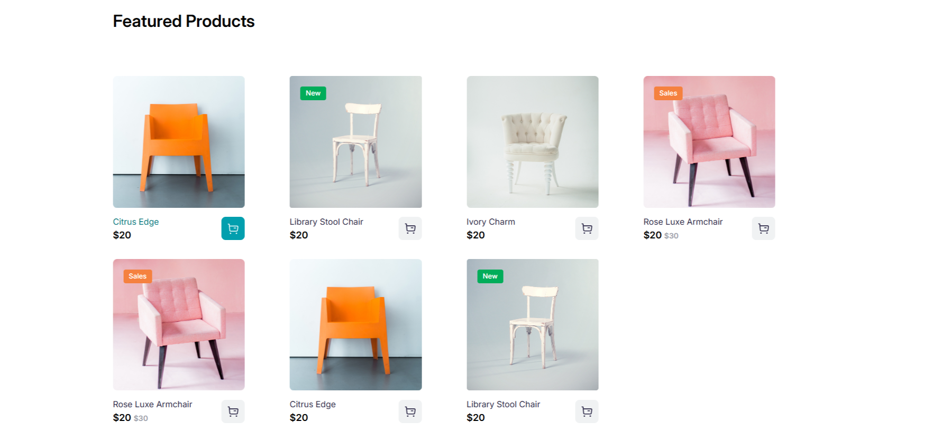

# Categories Component:

This component shows all the categories made and gives users access to them to click on it and view their products.

The code of this component is:

"use client";

import { useEffect, useState } from "react";

import Link from "next/link";

import axios from "axios";

import { urlFor } from "@/sanity/lib/image";

*const* Categories = () *=>* {

*interface* Category{

    id: *string*;

    title: *string*;

    image: {

      _type: *string*;

      asset: {

        _ref: *string*;

      };

    },

    _id:*string*

  }

*const* [categories,setCategories] = useState<Category[]>([]);

  async *function* getData(*path*:*string*,*set*:*boolean*){

*const* resp= await axios.get(*path*);

    if(*set*){

    setCategories(resp.data);

    }

    else{

      return resp.data.length;

    }

  }

  useEffect(

    ()*=>*{

      getData("/api/fetch/category",true);

    }

  )

    return (

      <div className='flex flex-col mt-[140.5px] pl-[15.625%] pr-[15.625%] gap-10 2xl:px-[15.625%] xl:px-[206px] lg:px-[175px] md:px-[100px] sm:px-[106px] exsm:px-[40px]'>

        <h3 className='font-inter font-semibold text-[32px]'>

        Categories</h3>

        <div className="grid grid-cols-3 gap-3 xl:gap-[200px] lg:grid-cols-2 md:grid-cols-2 md:gap-[100px] sm:grid-cols-2 sm:gap-[100px] exsm:flex exsm:flex-col exsm:items-center exsm:gap-6">

        {

            categories.map((*category*:Category,*index*:*number*)*=>*{

*const* imgUrl = urlFor(*category*.image);

                return(

                    <div key={*index*}>

                        <*Link* href={`/components/categoryItem/${*category*._id}?category=${*category*.title}`}>

                        <div className="h-[339.2px] w-[339.2px] flex bg-cover

                    rounded-[14px] flex-col justify-end sm:h-[250px] sm:w-[250px] exsm:h-[250px] exsm:w-[250px]"

                        style={{backgroundImage:`url(${imgUrl})`}}>

                            <div className="flex w-full h-[68px] bg-[rgba(0,0,0,0.7)]

                            rounded-b-[14px]">

                            <div className="flex flex-col gap-1 m-3">

                            <p className="text-white font-inter

                             text-[20px] font-semibold">{*category*.title}</p>

                            <p className="font-inter text-white

                            text-[14px]"></p>

                            </div>

                            </div>

                    </div>

                    </*Link*>

                    </div>

                )

            })

        }

        </div>

      </div>

    )

  }

export default Categories;

## Output:

The output is:

"use client";

import { useEffect, useState } from "react";

import Link from "next/link";

import axios from "axios";

import { urlFor } from "@/sanity/lib/image";

*const* Categories = () *=>* {

*interface* Category{

    id: *string*;

    title: *string*;

    image: {

      _type: *string*;

      asset: {

        _ref: *string*;

      };

    },

    _id:*string*

  }

*const* [categories,setCategories] = useState<Category[]>([]);

  async *function* getData(*path*:*string*,*set*:*boolean*){

*const* resp= await axios.get(*path*);

    if(*set*){

    setCategories(resp.data);

    }

    else{

      return resp.data.length;

    }

  }

  useEffect(

    ()*=>*{

      getData("/api/fetch/category",true);

    }

  )

    return (

      <div className='flex flex-col mt-[140.5px] pl-[15.625%] pr-[15.625%] gap-10 2xl:px-[15.625%] xl:px-[206px] lg:px-[175px] md:px-[100px] sm:px-[106px] exsm:px-[40px]'>

        <h3 className='font-inter font-semibold text-[32px]'>

        Categories</h3>

        <div className="grid grid-cols-3 gap-3 xl:gap-[200px] lg:grid-cols-2 md:grid-cols-2 md:gap-[100px] sm:grid-cols-2 sm:gap-[100px] exsm:flex exsm:flex-col exsm:items-center exsm:gap-6">

        {

            categories.map((*category*:Category,*index*:*number*)*=>*{

*const* imgUrl = urlFor(*category*.image);

                return(

                    <div key={*index*}>

                        <*Link* href={`/components/categoryItem/${*category*._id}?category=${*category*.title}`}>

                        <div className="h-[339.2px] w-[339.2px] flex bg-cover

                    rounded-[14px] flex-col justify-end sm:h-[250px] sm:w-[250px] exsm:h-[250px] exsm:w-[250px]"

                        style={{backgroundImage:`url(${imgUrl})`}}>

                            <div className="flex w-full h-[68px] bg-[rgba(0,0,0,0.7)]

                            rounded-b-[14px]">

                            <div className="flex flex-col gap-1 m-3">

                            <p className="text-white font-inter

                             text-[20px] font-semibold">{*category*.title}</p>

                            <p className="font-inter text-white

                            text-[14px]"></p>

                            </div>

                            </div>

                    </div>

                    </*Link*>

                    </div>

                )

            })

        }

        </div>

      </div>

    )

  }

export default Categories;

## Output: The output is: